Ethan Allen Slim Marble Dining Set

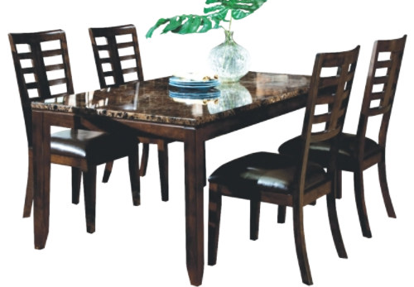

|  |
| --- |
| **DESCRIPTION** |
| Ethan Allen introduces stylish four legged balanced chairs which is perfect for stable surrounding. Four long table legs makes it easy for people sitting to adjust their legs inside the table and the marble disk which is used above the table is very strong and build to hold weights without getting cracked. |

|  |  |  |
| --- | --- | --- |
| **Price** | **1700$** | |
| **Dimensions** | **Table H** x **W** x **L** | **54in x 44in x 60in** |
| **Chairs H** x **W** x **L** | **45in x 30in x 33in** |
| **Features** | **The four chairs which have soft form seat which is very comfortable and has long legs which enables chairs to stay balance even on high pressure.** | |
| **Finished** | **Leather Shine Brown Polished** | |
| **Available in** | **Brown and Black** | |